Professor Paul Boyle – Chair

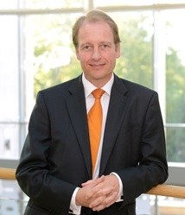
Professor Paul Boyle is President and Vice-Chancellor of the University of Leicester. Previously he was, Chief Executive of the Economic and Social Research Council (ESRC), the UK’s largest funding agency for social science research; the International Champion of Research Councils UK, with responsibility for international strategy on behalf of all seven UK research councils; and President of Science Europe, representing over 50 European funding agencies. He is a Fellow of the British Academy, the Royal Society of Edinburgh, the Academy of Social Sciences, and the Royal Geographical Society of Scotland.

Before joining the ESRC, Professor Boyle was Head of the School of Geography and Geosciences at the University of St Andrews, publishing widely in Demography and Epidemiology. He was Director of the ESRC Longitudinal Studies Centre Scotland, Co-Director of the ESRC Centre for Population Change, and Co-Investigator on the Wellcome Trust Scottish Health Informatics Programme. He was Founding Director of the Social Dimensions of Health Institute, a joint collaboration between the Universities of Dundee and St Andrews.

Professor Boyle is an ‘impact champion’ for the United Nations HeForShe global solidarity movement for gender equality; a Council Member and Trustee of the Association of Commonwealth Universities, which has over 500 member institutions in 37 Commonwealth countries; Chair of the Q-Step Strategy Board, promoting quantitative social science training in the UK; on the Advisory Board of the UPP Foundation; and the Advisory Board of Sporting Equals, promoting ethnic diversity in sport and physical activity. He received a CBE in December 2015 for services to Social Science.

Professor Paul Boyle joined the SSAC as Chair on 01 February 2016.

Professor Iain Hunter
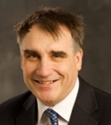
Professor Iain Hunter is Research Professor in Molecular Microbiology at the University of Strathclyde. Previously, he was Executive Dean of Science (2008-2014) and Vice-Dean Resources and Planning (2002-2008).

With a BSc (Hons) in Biochemistry, PhD in Microbial Physiology (both Glasgow University) and Research Fellowship in Microbial Genetics (Cambridge), he has expertise across the biomolecular sciences. He worked in industry (Pfizer UK and the USA) on antibiotic discovery and development, and has acted as a programme manager at the industrial interface on secondment to the Research Councils.

Professor Hunter is committed to translational research, being involved in 4 SME start-ups in drug discovery, and drug production by bioprocessing. He was involved in bidding (2013) for the initial funding for the Scottish Innovation Centre in Industrial Biotechnology (IB), which has ambitious targets for growing IB in Scotland.

As an academic teacher, he has particular interest in the transition between secondary and tertiary education, when many students struggle. He was involved in framing the Curriculum for Excellence course in Biology and has been both a Vetter and Scrutineer in Biology for the SQA.

Professor Iain Hunter joined the SSAC on 01 February 2016.

Professor Colin McInnes
Professor Colin McInnes is James Watt Chair, Professor of Engineering Science at the University of Glasgow.‌ His previous posts were Director, Advanced Space Concepts Laboratory and Director, Scottish Centre of Excellence in Satellite Applications at the University of Strathclyde, where he retains a Visiting Research Professorship.

Professor McInnes’ research interests cover the broad application of mathematical modelling to a range of problems in Engineering Science including satellite orbital dynamics, smart structures and swarming robotic systems. He is also engaged in research on long-term, large-scale ventures in Engineering Science for applications including climate engineering and the utilisation of space resources.

He is a Fellow of the Royal Society of Edinburgh and the Royal Academy of Engineering and was made MBE in June 2014 for services to Space Research, Science and Technology. He is currently a Royal Society Wolfson Research Merit Award holder.

Professor Colin McInnes joined the SSAC on 01 February 2016.

Professor Anna Meredith

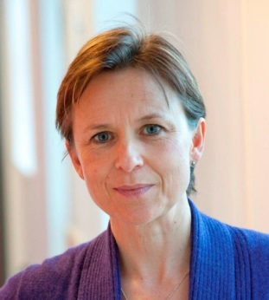
Professor Anna Meredith holds a personal Chair of Zoological and Conservation Medicine at the Royal (Dick) School of Veterinary Studies / Roslin Institute, University of Edinburgh. She graduated from University of Oxford (MA Physiological Sciences), University of Cambridge (Bachelor of Veterinary Medicine) and University of Edinburgh (PhD), and is a Royal College of Veterinary Surgeons (RCVS) Recognised Specialist in Zoological Medicine and a European College of Zoological Medicine (ECZM) Specialist in Wildlife Population Health.

Professor Meredith has 25 years veterinary clinical and research experience in wild animal health and welfare, is Head of the Exotic Animal and Wildlife Unit and was Head Veterinary Surgeon for the Royal Zoological Society of Scotland’s Edinburgh Zoo for over 17 years. Anna currently chairs the UK Government’s Zoos Expert Committee, an internal advisory body to Defra on zoo matters, aiming to encourage the role of zoos in conservation, education and scientific research. She is also a Scottish Government Zoo Inspector.

Professor Meredith has recently served as a Trustee and Vice-President on the Council of the Zoological Society of London and is currently retained as a strategic advisor.

Her research interests lie at the interface between human, animal and ecosystem health (One Health), with a focus on infectious diseases of wildlife and the conservation of Scottish wildlife. She is a member of the Steering Group of the Scottish Wildcat Conservation Action Plan, and her research projects include red squirrel disease, and Scottish raptor health as an indicator of ecosystem health. She is also Director of Postgraduate Taught Programmes for the College of Medicine and Veterinary Medicine at the University of Edinburgh

Professor Meredith is a member of the Scottish Universities Athena SWAN network and chairs the vet school’s Athena SWAN / Career Support Committee, working to promote gender equality across academia.

Professor Anna Meredith joined the SSAC on 01 February 2016.

Professor Andy Mount

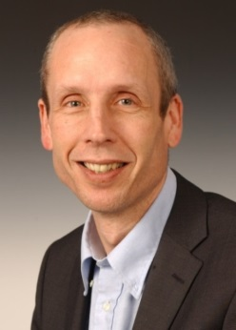
Professor Andy Mount is Professor of Physical Electrochemistry and Dean of Research in the College of Science & Engineering (CSE) at the University of Edinburgh.

His research interests include fundamental and applied electrochemistry, sensing and analysis and the development and application of healthcare and low carbon clean energy technologies; he has played a leading role in over £40million of major multidisciplinary collaborations across Scotland, the UK and Europe. As Director of Research he played a key role in the establishment of EaStCHEM, the joint chemistry research School of the Universities of Edinburgh and St Andrews, and he coordinated the highly successful CSE REF2014 submissions as Dean of REF. As Dean of Research he is now leading CSE research and impact strategy and development.

He is a Fellow of the Royal Society of Chemistry (RSC), Chair of the RSC Faraday Standing Committee on Conferences and a member of RSC Faraday Division Council. He is also member of the Science Advisory Committee of the Scottish Universities Environmental Research Centre, is external examiner for Chemistry degrees at the University of Warwick and was previously external examiner for Chemistry at the University of Bath.

Professor Andy Mount joined the SSAC on 01 February 2016.

Professor Susan Rosser

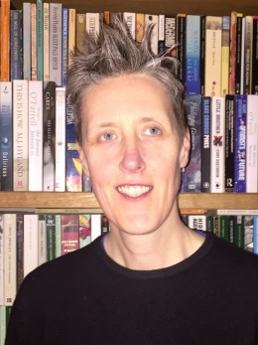
Professor Susan Rosser is Professor of Synthetic Biology at the University of Edinburgh. She is Director of the Edinburgh Mammalian Synthetic Biology Research Centre, PI and Co-director of the Edinburgh Genome Foundry for synthetic DNA synthesis and assembly. She also holds a prestigious EPSRC Leadership Fellowship in Synthetic Biology. She also leads two, large transatlantic Synthetic Biology research consortia funded by the EPSRC/NSF (Berkeley, Northwestern, Imperial, Warwick, Edinburgh) and BBSRC/NSF (Stanford, MIT, Penn State, Imperial, Edinburgh).

Professor Rosser’s research focuses on developing tools for synthetic biology approaches for pathway and genome engineering in bacteria, yeast and mammalian cell systems. The applications of her work include rapid strain engineering for production of high value chemicals, cell lines for protein production in particular biologic therapeutics, developing genetic tools for engineering stem cells and bio-computation: engineering cells to sense, process and memorise information.

Professor Rosser is a member of the Scottish Industrial Biotechnology Development Group and has translated her research for the commercial sector working closely with industry and has projects funded with both multinationals and local SMEs.

Professor Susan Rosser joined the SSAC on 01 February 2016

Dr Tara Spires-Jones
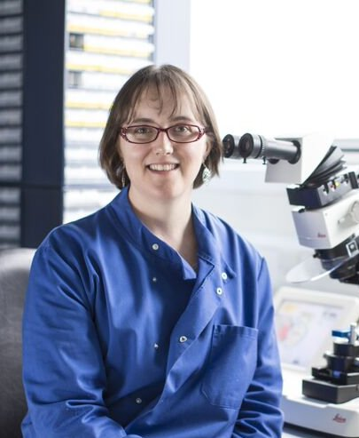
Dr Tara Spires-Jones is a Neuroscientist running a research group at the University of Edinburgh.

Dr Spires-Jones’ research focuses on the mechanisms and reversibility of brain degeneration in Alzheimer’s disease, other degenerative brain diseases, and ageing. Her work has shown that both of the proteins involved in the neuropathological lesions in AD (amyloid beta and tau) contribute to brain degeneration, and further that reducing the levels of these proteins prevents degeneration and improves memory in disease models.

Prior to moving to Scotland in 2013, she ran a group studying Alzheimer’s disease pathogenesis with an emphasis on synaptic pathology at Massachusetts General Hospital and Harvard Medical School, where she was an instructor from 2006-2011 and Assistant Professor from 2011-2013. She is a FENS-KAVLI Network of Excellence scholar working to foster the careers of early-career scientists through scientific exchanges, influencing science policy, and facilitating exchange between science and society.

Dr Tara Spires-Jones joined the SSAC on 01 February 2016.

